**Exercise 02_04_01 – Step 1**

In this Exercise, we will learn how to manage user interactions with PHP.

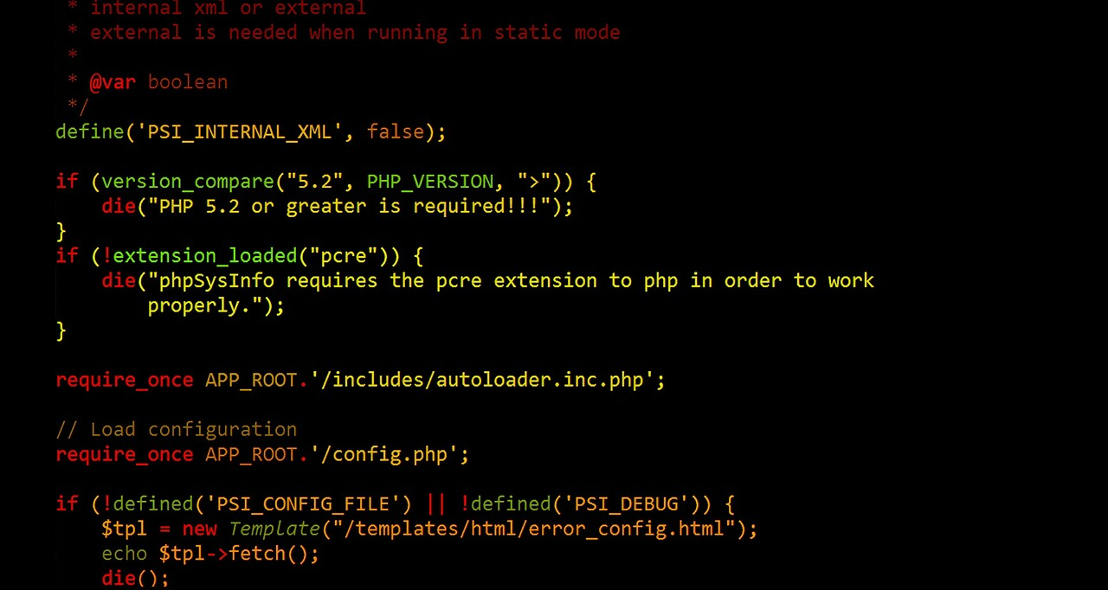

1. Create a folder named Exercise 02_04_01 and open it with your IDE. Create a new file called ***Superglobals.php***. Scaffold a basic HTML code layout into it. Complete our standard opening documentation in the ***<head>*** element. Make sure to have the ***modernizr*** <script> linked in. Set the <title> content to ***Superglobals***:  
   ***<!DOCTYPE html>  
   <html lang="en">  
   <head>  
    <meta charset="utf-8">  
    <meta name="viewport" content="width=device-width">  
    <title>Superglobals</title>  
    <script src="modernizr.custom.65897.js"></script>  
   </head>  
   <body>  
   </body>  
   </html>***
2. In the <body>, create an ***<h2>*** element with content ***Superglobals***. Create a set of PHP standard script delimiters.  
    ***<h2>Superglobals</h2>  
    <?php  
     
    ?>***Copy the project folder into the appropriate spot on your Web Server and test it.
3. Insert the following code into the script section to use the ***$_SERVER*** superglobal:  
    <?php  
    ***echo "<h3>Superglobal Array \$_SERVER[]</h3>";  
    echo "<p>The name of the current script is: ",   
    $_SERVER["SCRIPT_NAME"], "<br>";  
    echo "This script was executed with the following server   
    software: ", $_SERVER["SERVER_SOFTWARE"], "<br>";  
    echo "This script was requested with the following server   
    protocol: ", $_SERVER["SERVER_PROTOCOL"], "<br>";  
    echo "This script is running on the following server name: ",   
    $_SERVER["SERVER_NAME"], "<br>"; ?>  
    echo "This script is running on the following server address:   
    ", $_SERVER["SERVER_ADDR"], "<br>";  
    echo "This script is running with the following gateway   
    interface: ", $_SERVER["GATEWAY_INTERFACE"], "<br>";  
    echo "This script is running with the following request   
    method: ", $_SERVER["REQUEST_METHOD"], "<p>";***Give this a browser/server test.

**Exercise 02_04_01 – Step 2**



1. Create a new file called ***Scholarship.html***. Scaffold a basic HTML code layout into it. Complete our standard opening documentation in the ***<head>*** element. Make sure to have the ***modernizr*** <script> linked in. Set the <title> content to ***Scholarship***:  
   ***<!DOCTYPE html>  
   <html lang="en">  
     
   <head>  
    <meta charset="utf-8">  
    <meta name="viewport" content="width=device-width">  
    <title>Scholarship</title>  
    <script src="modernizr.custom.65897.js"></script>  
   </head>  
   <body>  
     
   </body>  
     
   </html>***
2. Add the following ***HTML*** content to the ***<body>***: *<body>* ***<h2 style="text-align: center">Scholarship Form</h2>  
    <form name="scholarship"   
    action="Process_Scholarship.php" method="post">  
    <p>First name: <input type="text" name="fName"></p>  
    <p>Last name: <input type="text" name="lName"></p>  
    <p>  
    <input type="reset" value="Clear Form">&nbsp;&nbsp;  
    <input type="submit" name="submit" value="Send   
    Form">  
    </p>  
    </form>****</body>*Give this a server/browser test.

**Exercise 02_04_01 – Step 3**



1. Copy the file ***Superglobals.php*** to a file named ***Process_Scholarship.php***, and open it with your IDE. Update the standard opening documentation in the ***<head>*** element. Set the <title> content to ***Process Scholarship.*** In the <body>, create an ***<h2>*** element with content ***Process Scholarship***. Create a set of PHP standard script delimiters:  
    ***<h2>Process Scholarship</h2>  
    <?php  
     
    ?>***Give this a server/browser test.
2. Add the following PHP code to the form handler to retrieve and display the form data:  
    ***$firstName = $_POST['fName'];  
    $lastName = $_POST['lName'];  
    echo "Thank you for filling out the scholarship form, " .   
    $firstName . " " . $lastName . ".";***Give this a server/browser test.
3. Modify the code to protect against Magic quotes as follows:  
    ***$firstName = stripslashes($_POST['fName']);  
    $lastName = stripslashes($_POST['lName']);***Give this a server/browser test.

**Exercise 02_04_01 – Step 4**



1. Copy the file ***Scholarship.html*** to a file named ***Scholarship2.html***, and open it with your IDE. Update the standard opening documentation in the ***<head>*** element. Set the <title> content to ***Process Scholarship 2.*** In the <body>, create an ***<h2>*** element with content ***Scholarship Form 2***. Change the <form> element action attribute:  
   ***<form name="scholarship"   
    action="Process_Scholarship2.php" method="post">***Give this a server/browser test.
2. Copy the file ***Process_Scholarship.php*** to a file named ***Process_Scholarship2.php***. Update the standard opening documentation in the ***<head>*** element. Set the <title> content to ***Process Scholarship 2.*** In the <body>, modify the ***<h2>*** element with content ***Process Scholarship 2***:  
    ***<h2>Process Scholarship 2</h2>***Give this a server/browser test.
3. Declare and initialize a global variable at the top of the script:  
    ***$errorCount = 0;***
4. Below that, add a new function named ***displayRequired()*** to the top of the script to handle error messages of empty required fields:  
    ***function displayRequired($fieldName) {  
    echo "The field \"$fieldName\" is required.<br>\n";  
    }***Give this a server/browser test.
5. Add a second new function below the first named ***validateInput()***.It will take two parameters, the first is the data to be validated, the second is the name of the field. If there is data in the field, it will do some cleanup. It will also globally track a count of the errors:  
    ***function validateInput($data, $fieldName) {  
    global $errorCount;  
    if (empty($data)) {  
    displayRequired($fieldName);  
    ++$errorCount;  
    $retval = "";  
    }  
    else {  
    $retval = trim($data);  
    $retval = stripslashes($retval);  
    }  
    return $retval;  
    }***Give this a server/browser test.
6. Modify the assignment statements for ***$firstName*** and ***$lastname*** to use the return from the ***validateInput()*** function:  
    ***$firstName = validateInput($_POST['fName'], "First name");  
    $lastName = validateInput($_POST['lName'], "Last name");***Give this a server/browser test.
7. Modify the ***echo*** output statement to either print the number of ***errors*** found, or the thank you statement:  
    ***if ($errorCount > 0) {  
    echo "$errorCount errors: Please use the \"Back\" button   
    to re-enter the data.<br>\n";  
    }  
    else {  
    echo "Thank you for filling out the scholarship form, $firstName $lastName.";***Give this a server/browser test.

**Exercise 02_04_01 – Step 5**



1. Open the file named ***Process_Scholarship2.php***. Add the following function below the other two functions to redisplay the Web form. Notice the exact use of the PHP script delimiters:   
    ***function redisplayForm($firstName, $lastName) {  
    ?>  
    <h2 style="text-align: center">Scholarship Form 2</h2>  
    <form name="scholarship"   
    action="Process_Scholarship2.php" method="post">  
    <p>First name: <input type="text" name="fName"   
    value="<?php echo $firstName; ?>"></p>  
    <p>Last name: <input type="text" name="lName"   
    value="<?php echo $lastName; ?>"></p>  
    <p>  
    <input type="reset" value="Clear Form">&nbsp;&nbsp;  
    <input type="submit" name="submit" value="Send   
    Form">  
    </p>  
    </form>  
    <?php  
    }***Give this a server/browser test.
2. Modify the ***if...else*** clause to ***redisplay*** the form if there were errors:  
    *if ($errorCount > 0) {* ***echo "$errorCount errors: Please re-enter the information   
    below.<br>\n";  
    redisplayForm($firstName, $lastName);*** *}*Give this a server/browser test.

**Exercise 02_04_01 – Step 6**



1. Copy the file ***Superglobals.php*** to a file named ***NumberForm.php***, and open it with your IDE. Update the standard opening documentation in the ***<head>*** element. Set the <title> content to ***Number Form.*** In the <body>, create an ***<h2>*** element with content ***Number Form***. Create a set of PHP standard script delimiters:  
    ***<h2>Number Form</h2>  
    <?php  
     
    ?>***Give this a server/browser test.
2. At the top of the script, create a ***$displayForm*** variable, to determine if the Web form should be redisplayed, and a ***$number*** variable to track the input:  
    ***$displayForm = true;  
    $number = "";***Give this a server/browser test.
3. Add the following code to check whether the form data has been entered. If it has, the data will be validated:  
    ***if (isset($_POST['Submit'])) {  
    $number = $_POST['number'];  
    if (is_numeric($number)) {  
    $displayForm = false;  
    }  
    else {  
    echo "<p>You need to enter a numeric value.</p>\n";  
    $displayForm = true;  
    }  
    }***Give this a server/browser test.
4. Enter the following code to display the form. Note the use of ***multiple*** PHP script ***delimiters***:  
    ***if ($displayForm) {  
    ?>  
    <form name="NumberForm" action="NumberForm.php"   
    method="post">  
    <p>  
    Enter a number: <input type="text" name="number"   
    value="<?php echo $number; ?>">  
    </p>  
    <p>  
    <input type="reset" value="Clear Form">&nbsp;&nbsp;  
    <input type="submit" name="Submit" value="Send   
    Form">  
    </p>  
    </form>  
    <?php  
    }  
    ?>***Give this a server/browser test.
5. Add an ***else*** clause to the script at the bottom, to inform the user if data has been entered correctly:  
    *<?php  
    }* ***else {  
    echo "<p>Thank you for entering a number.</p>\n";  
    echo "<p>Your number, $number, squared is " .   
    ($number * $number) . ".</p>\n";  
    echo "<p><a href=\"Numberform.php\">  
    Try again?</a></p>\n";  
    }*** *?>*Give this a server/browser test.

**Exercise 02_04_01 – Step 7**



1. Create a new file named ***inc_header.html***, and open it with your IDE. Place the following minimal HTML in the file:  
   ***<h1 style="text-align: center">Sample Web Template</h1>***
2. Create a new file named ***inc_footer.php***, and open it with your IDE. Place the following minimal code in the file:  
   ***<p>Todays Date: <?php echo date('r'); ?></p>***
3. Create a new file named ***inc_home.html***, and open it with your IDE. Place the following minimal HTML code in the file:  
   ***<h2>Home Page</h2>  
   <p>This is the default home page that displays  
   whenever a new visitor comes to the site.</p>***
4. Create a new file named ***inc_about.html***, and open it with your IDE. Place the following minimal HTML code in the file:  
   ***<h2>About Me</h2>  
   <p>This is the page that tells about me and my Web site.</p>***
5. Create a new file named ***inc_contact.html***, and open it with your IDE. Place the following minimal HTML code in the file:  
   ***<h2>Contact Me</h2>  
   <p>This is the page where people can use a Web form to send   
    me an e-mail.</p>***
6. Create a new file named ***inc_buttonnav.html***, and open it with your IDE. Place the following minimal HTML code in the file:  
   ***<form action="WebTemplate.php" method="get">  
    <input type="submit" name="content"   
    value="Home"><br>  
    <input type="submit" name="content" value="About   
    Me"><br>  
    <input type="submit" name="content" value="Contact   
    Me"><br>  
   </form>***
7. Copy the file ***Superglobals.php*** to a file named ***WebTemplate.php***. Update the standard opening documentation in the ***<head>*** element. Set the <title> content to ***WebTemplate.*** In the <body> remove all of the code.
8. Add the following code to the <body> of the document. Incrementally test in the browser/server, line by line:  
   *<body>* ***<?php include("inc_header.html") ?>  
    <div style="width: 20%; text-align: center; float: left">  
    <?php include("inc_buttonnav.html") ?>  
    </div>  
    <!-- Start of dynamic content section -->  
    <?php  
    ?>  
    <!-- End of dynamic content section -->  
    <?php include("inc_footer.php") ?>****</body>*
9. Place the following code between the PHP delimiters in the Dynamic Content Section:  
    <?php  
    ***if (isset($_GET['content'])) {  
    switch ($_GET['content']) {  
    case 'About Me':  
    include("inc_about.html");  
    break;  
    case 'Contact Me':  
    include("inc_contact.html");  
    break;  
    case 'Home':  
    // A value of home means to  
    // display the default page  
    default:  
    include("inc_home.html");  
    break;  
    }  
    }  
    else { // no button selected  
    include("inc_home.html");  
    }*** ?>  
   Give this a full browser/server test.